2-4A Open Boys
Place | Bib # | Name | Gun Elapsed | Gender | Division
1 | 410 | Damian Hernandez | 00:18:44.8 | M | 24A Open Boys
2 | 415 | Emiliano Medina | 00:19:25.0 | M | 24A Open Boys
3 | 417 | Bryan Meraz | 00:21:18.2 | M | 24A Open Boys
4 | 404 | Jariel Espinoza | 00:21:25.6 | M | 24A Open Boys
5 | 414 | Kevin Martinez | 00:22:15.2 | M | 24A Open Boys
6 | 403 | Moises Diaz | 00:22:26.8 | M | 24A Open Boys
7 | 570 | Andy Trejo | 00:22:55.8 | M | 24A Open Boys
8 | 586 | Miguel Rodriguez | 00:22:59.2 | M | 24A Open Boys
9 | 402 | Angel Contreras | 00:23:17.7 | M | 24A Open Boys
10 | 416 | Justin Melendez | 00:23:17.8 | M | 24A Open Boys
11 | 409 | Dillon Hernandez | 00:24:34.0 | M | 24A Open Boys
12 | 567 | Diego Carrillo | 00:25:11.2 | M | 24A Open Boys
13 | 569 | Jorge Holguin | 00:25:33.5 | M | 24A Open Boys
14 | 565 | Alfredo Alvarado | 00:27:07.3 | M | 24A Open Boys
15 | 587 | Zadquiel Rodriguez | 00:28:32.7 | M | 24A Open Boys
1-4A Open Boys
16 | 585 | Angel Rodriguez | 00:29:20.4 | M | 24A Open Boys
Place | Bib # | Name | Gun Elapsed | Gender | Division
1 | 518 | David Retana | 00:20:02.7 | M | 14A Open Boys
2 | 451 | Isaiah Candelaria | 00:20:29.6 | M | 14A Open Boys
3 | 455 | Jose Lopez | 00:20:43.0 | M | 14A Open Boys
4 | 512 | Victor Hernandez | 00:21:10.7 | M | 14A Open Boys
5 | 523 | Carlo Silva | 00:21:16.1 | M | 14A Open Boys
6 | 439 | Ares Arredondo | 00:21:18.8 | M | 14A Open Boys
7 | 517 | Adrian Rentas Quiles | 00:21:18.8 | M | 14A Open Boys
8 | 506 | Aaron Caballero | 00:21:44.0 | M | 14A Open Boys
9 | 456 | Luis Rodriguez | 00:22:23.7 | M | 14A Open Boys
10 | 507 | Sergio Candelaria | 00:22:32.0 | M | 14A Open Boys
11 | 515 | Miguel Padilla | 00:22:45.2 | M | 14A Open Boys
12 | 505 | Yadriel Batine Moreta | 00:22:46.1 | M | 14A Open Boys
13 | 509 | Martin Chiw | 00:22:50.8 | M | 14A Open Boys
14 | 522 | Braulio Silva | 00:23:01.0 | M | 14A Open Boys
15 | 508 | Dominic Carrillo | 00:23:07.2 | M | 14A Open Boys
16 | 510 | Bryan Grjalva | 00:23:28.8 | M | 14A Open Boys
17 | 452 | Juan Esparza | 00:23:35.8 | M | 14A Open Boys
18 | 448 | Jesus Palacio | 00:23:52.1 | M | 14A Open Boys
19 | 519 | Nathan Reyes | 00:23:59.9 | M | 14A Open Boys
20 | 511 | Sheldon Harris | 00:25:28.3 | M | 14A Open Boys
21 | 453 | Joaquin Figueroa | 00:25:38.4 | M | 14A Open Boys
22 | 594 | Cesar Corral | 00:29:08.4 | M | 14A Open Boys
23 | 521 | Gael Rincon | 00:29:18.3 | M | 14A Open Boys
24 | 454 | Aaron Huerta | 00:30:12.8 | M | 14A Open Boys
25 | 504 | Atreyu Aipperspach | 00:41:26.8 | M | 14A Open Boys
2-4A Open Girls
Place | Bib # | Name | Gun Elapsed | Gender | Division
1 | 489 | Veronica Ramos | 00:14:55.6 | F | 24A Open Girls
2 | 407 | Nathaly Gomez | 00:15:34.6 | F | 24A Open Girls
3 | 557 | Azury Contreras | 00:16:22.2 | F | 24A Open Girls
4 | 408 | Evelyn Hernandez | 00:16:23.7 | F | 24A Open Girls
5 | 413 | Karol Madrid | 00:18:10.0 | F | 24A Open Girls
6 | 411 | Sarahi Hernandez | 00:18:15.2 | F | 24A Open Girls
7 | 562 | Karla Murillo | 00:18:18.1 | F | 24A Open Girls
8 | 490 | Jin Song | 00:18:41.6 | F | 24A Open Girls
9 | 485 | Sofia McMahon | 00:18:43.0 | F | 24A Open Girls
10 | 556 | Genesis Anguiano | 00:18:47.4 | F | 24A Open Girls
11 | 484 | Rhianon Baeza | 00:18:48.7 | F | 24A Open Girls
12 | 412 | Geidy Limones | 00:19:21.8 | F | 24A Open Girls
13 | 560 | Carla Herrera | 00:19:35.8 | F | 24A Open Girls
14 | 486 | Donetta Moreno | 00:19:41.8 | F | 24A Open Girls
15 | 561 | Anais Marrufo | 00:20:09.5 | F | 24A Open Girls
16 | 590 | Yadhira Loya | 00:20:09.9 | F | 24A Open Girls
17 | 488 | Kareena Ortiz | 00:20:21.1 | F | 24A Open Girls
18 | 588 | Angelica Cardoza | 00:20:43.3 | F | 24A Open Girls
19 | 559 | Valentina Hernandez | 00:20:59.5 | F | 24A Open Girls
20 | 491 | Josilyn Wilson | 00:21:06.3 | F | 24A Open Girls
21 | 401 | Bianca Avalos | 00:26:26.5 | F | 24A Open Girls
1-4A Open Girls
Place | Bib # | Name | Gun Elapsed | Gender | Division
1 | 463 | Paula Tapia | 00:15:44.0 | F | 14A Open Girls
2 | 457 | Yesenia Carmona | 00:16:11.6 | F | 14A Open Girls
3 | 526 | Camila Garcia-Rocha | 00:16:53.1 | F | 14A Open Girls
4 | 462 | Allyson Rodriguez | 00:17:20.8 | F | 14A Open Girls
5 | 459 | Eileen Garcia | 00:17:23.3 | F | 14A Open Girls
6 | 458 | Louisiana Chavez | 00:17:26.5 | F | 14A Open Girls
7 | 591 | Ana Aguilar | 00:17:47.5 | F | 14A Open Girls
8 | 461 | Amberlin Parra | 00:18:03.6 | F | 14A Open Girls
9 | 529 | Layla Leon-Contreras | 00:18:29.1 | F | 14A Open Girls
10 | 531 | Alexa Silva | 00:18:44.1 | F | 14A Open Girls
11 | 593 | Itzel Olivos | 00:19:32.1 | F | 14A Open Girls
12 | 528 | Priscilla Hernandez | 00:19:50.6 | F | 14A Open Girls
13 | 460 | Pamela Gomez | 00:21:05.0 | F | 14A Open Girls
14 | 530 | Danelly Palacios | 00:22:06.4 | F | 14A Open Girls
15 | 527 | Maritza Hernandez | 00:27:34.3 | F | 14A Open Girls
2-5A 9th Grade Girls
Place | Bib # | Name | Gun Elapsed | Team | Division
1 | 571 | Emma Reyes | 00:17:24.0 | Del Valle | 25A 9th Girls
2 | 548 | Aida Xol Bol | 00:17:38.3 | Ysleta | 25A 9th Girls
3 | 525 | Selene Dean | 00:18:17.3 | Horizon | 25A 9th Girls
4 | 545 | Daniela Garduno | 00:18:37.1 | Ysleta | 25A 9th Girls
5 | 546 | Heydi Ico Choc | 00:22:18.4 | Ysleta | 25A 9th Girls
2-5A 9th Grade Boys
Place | Bib # | Name | Gun Elapsed | Gender | Division
1 | 535 | Tristan Pantoja | 00:13:25.9 | M | 25A 9th Boys
2 | 542 | Matthew Velasco | 00:13:28.2 | M | 25A 9th Boys
3 | 534 | Hector Navarrete | 00:13:38.8 | M | 25A 9th Boys
4 | 532 | Patrick Castillo | 00:13:54.9 | M | 25A 9th Boys
5 | 540 | Jason Puentes | 00:14:09.8 | M | 25A 9th Boys
6 | 572 | Julian Ortega | 00:14:32.3 | M | 25A 9th Boys
7 | 533 | Avyel Leyva | 00:15:06.6 | M | 25A 9th Boys
8 | 537 | Mauricio Velez | 00:15:07.3 | M | 25A 9th Boys
9 | 538 | Jake Jimenez | 00:15:11.2 | M | 25A 9th Boys
10 | 536 | Noah Remes | 00:15:20.6 | M | 25A 9th Boys
11 | 541 | Estrada Sergio | 00:18:41.3 | M | 25A 9th Boys
2-5A Open Girls
Place | Bib # | Name | Gun Elapsed | Gender | Division
1 | 424 | Alina Levario | 00:22:47.6 | F | 25A Open Girls
2 | 428 | Summer Trejo | 00:23:50.3 | F | 25A Open Girls
3 | 465 | Marlene Coronado | 00:23:55.4 | F | 25A Open Girls
4 | 470 | Jacqueline Viramontes | 00:24:35.6 | F | 25A Open Girls
5 | 551 | Janett Gonzalez | 00:24:44.1 | F | 25A Open Girls
6 | 466 | Angelica Dominguez | 00:24:44.2 | F | 25A Open Girls
7 | 469 | Andrea Moreno | 00:24:58.7 | F | 25A Open Girls
8 | 426 | Alexis Priego | 00:25:13.5 | F | 25A Open Girls
9 | 464 | Ashley Acosta | 00:25:26.4 | F | 25A Open Girls
10 | 425 | Madisyn McMillan | 00:26:00.6 | F | 25A Open Girls
11 | 427 | Kaitlyn Roldan | 00:26:11.7 | F | 25A Open Girls
12 | 467 | Melissa Gonzalez | 00:26:43.9 | F | 25A Open Girls
13 | 553 | Marlene Quezada | 00:27:02.2 | F | 25A Open Girls
14 | 423 | Kailah Acosta | 00:27:26.1 | F | 25A Open Girls
15 | 550 | Yareshli Diaz | 00:28:25.4 | F | 25A Open Girls
16 | 549 | Garcia Briana | 00:28:31.3 | F | 25A Open Girls
17 | 552 | Domenica Guaman | 00:29:25.7 | F | 25A Open Girls
18 | 503 | Faith Gonzalez | 00:30:12.4 | F | 25A Open Girls
19 | 468 | Araceli Mata | 00:30:38.2 | F | 25A Open Girls
2-5A Open Boys
Place | Bib # | Name | Gun Elapsed | Gender | Division
1 | 474 | Pablo Fuentes | 00:17:55.5 | M | 25A Open Boys
2 | 471 | Isai Alvarado | 00:18:32.5 | M | 25A Open Boys
3 | 430 | Noah Arias | 00:19:04.4 | M | 25A Open Boys
4 | 431 | Ky'Ri Bonner | 00:19:13.3 | M | 25A Open Boys
5 | 477 | Steven Lozano | 00:19:17.9 | M | 25A Open Boys
6 | 473 | Joaquin Elizondo | 00:19:23.9 | M | 25A Open Boys
7 | 434 | Gael Marquez | 00:19:26.2 | M | 25A Open Boys
8 | 479 | Iram Luna | 00:19:40.3 | M | 25A Open Boys
9 | 482 | Robert Munoz | 00:19:49.0 | M | 25A Open Boys
10 | 577 | Javier Ibarra | 00:19:54.7 | M | 25A Open Boys
11 | 476 | Luis Jimenez | 00:20:11.6 | M | 25A Open Boys
12 | 483 | Hazyel Salas | 00:20:18.0 | M | 25A Open Boys
13 | 429 | Aiden Alvarez | 00:20:18.2 | M | 25A Open Boys
14 | 438 | David Uriel | 00:20:37.1 | M | 25A Open Boys
15 | 436 | Diego Rodriquez | 00:20:50.3 | M | 25A Open Boys
16 | 475 | Timothy Haggerty | 00:20:56.7 | M | 25A Open Boys
17 | 492 | Iszak Gomez | 00:21:29.9 | M | 25A Open Boys
18 | 500 | Juan Villalobos | 00:21:34.1 | M | 25A Open Boys
19 | 493 | Xavior Jimenez | 00:21:35.6 | M | 25A Open Boys
20 | 574 | Andres Arzola | 00:21:37.5 | M | 25A Open Boys
21 | 573 | Andres Alvidrez | 00:21:47.3 | M | 25A Open Boys
22 | 435 | Juan Murillo | 00:22:01.7 | M | 25A Open Boys
23 | 575 | Irving Dominguez | 00:22:01.9 | M | 25A Open Boys
24 | 497 | Adrian Romero | 00:22:28.6 | M | 25A Open Boys
25 | 499 | Samuel Sandoval | 00:22:37.5 | M | 25A Open Boys
26 | 480 | Edgar Martinez | 00:22:37.9 | M | 25A Open Boys
27 | 432 | Sergio Hernandez | 00:23:06.9 | M | 25A Open Boys
28 | 481 | Alejandro Morales | 00:23:59.0 | M | 25A Open Boys
29 | 501 | KEVIN VILLARREAL | 00:24:17.3 | M | 25A Open Boys
30 | 498 | Carlos Ronquillo | 00:24:18.8 | M | 25A Open Boys
31 | 433 | Aldo Marquez | 00:24:27.7 | M | 25A Open Boys
32 | 478 | Manuel Lozoya | 00:26:26.9 | M | 25A Open Boys
33 | 494 | Cristian Meza | 00:32:10.7 | M | 25A Open Boys

TEAM SCORES

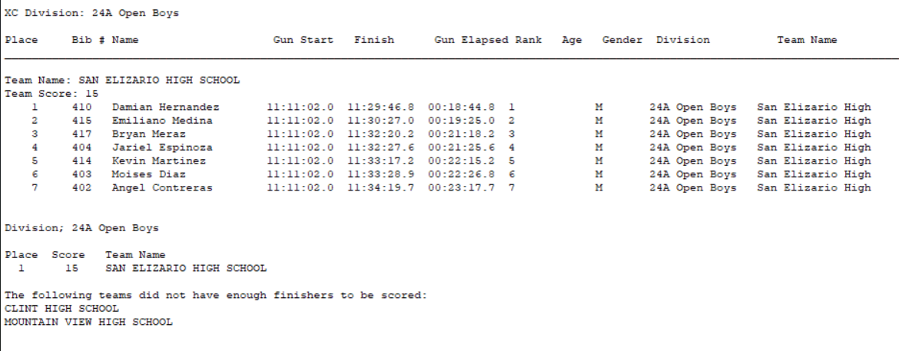

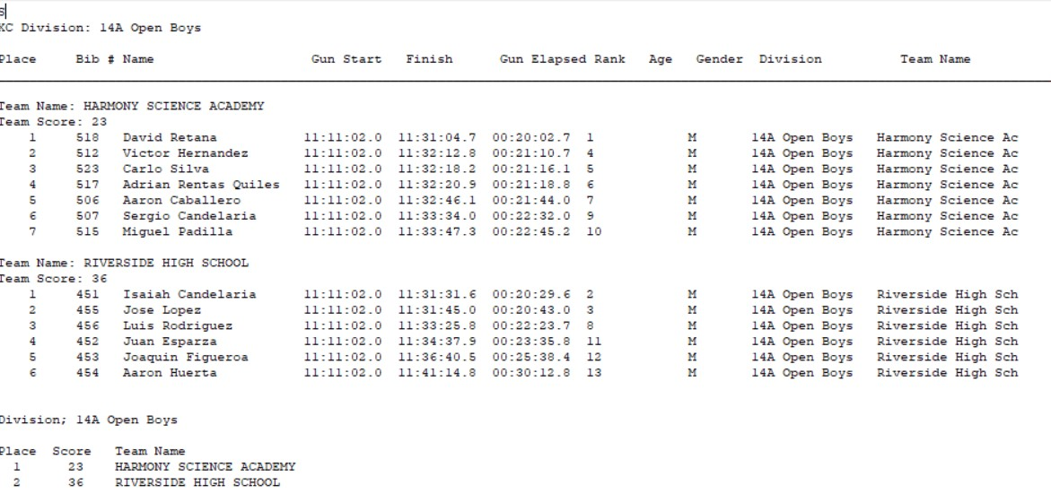

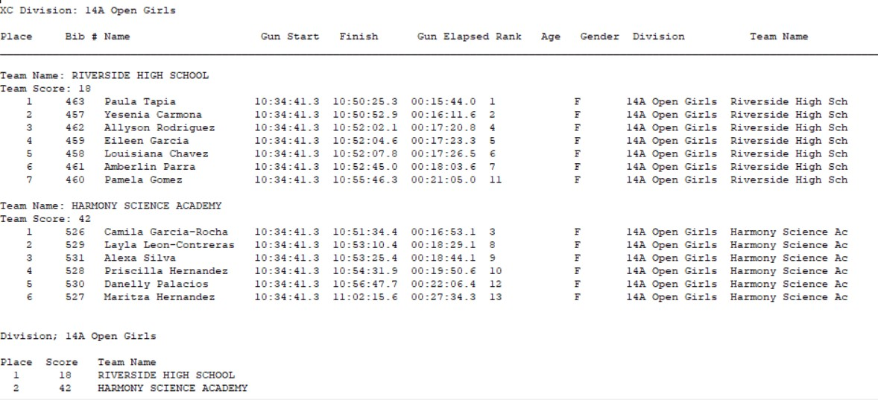
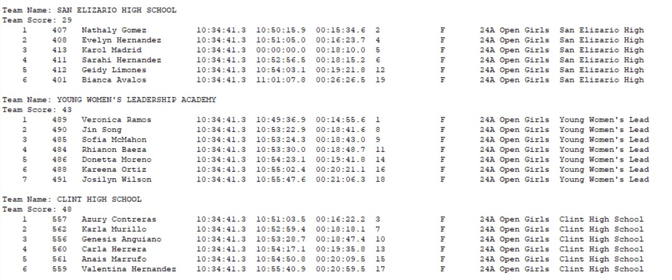
2-4A Open Girls

